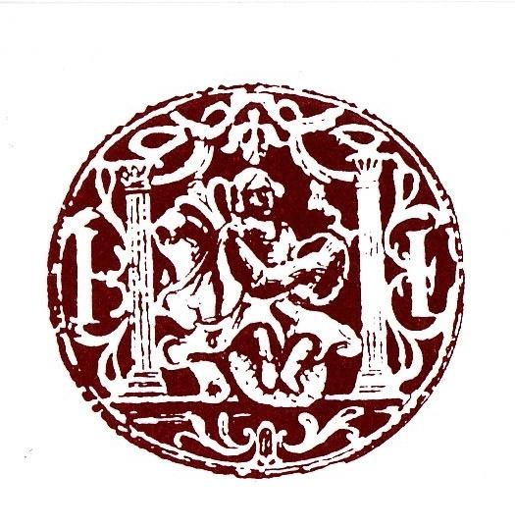
The Friends of
St Cecilia’s Hall
present
Sounds
of St Cecilia’s

Friday 15 August 2025 at 3pm

The Early Jazz Clarinet

Sir Nicholas Shackleton Concert

Tom Gibbs – Clarinet
Alex Handyside – Guitar
Timmy Allan – Bass

Details of the programme will be announced by the musicians. It will include pieces by Bix Beiderbecke, WC Handy and Jelly Roll Morton, alongside early jazz standards.

Performers

Tom Gibbs performs on piano and clarinet. Recent performances have been with the Matt Carmichael Quintet, Ewan Hastie Trio, Brian Molley Quartet and around Europe with the Siobhan Miller Band. The 2012 album Fear of Flying, was released on Whirlwind Recordings and features his own compositions. He teaches in Glasgow on the Royal Conservatoire of Scotland’s jazz course.

Alex Handyside is a Glasgow based guitarist. Having recently graduated from the Jazz programme at the Royal Conservatoire of Scotland, Alex performs regularly as part of Scotland’s thriving jazz scene. He has performed as part of the world-renowned Celtic Connections and Fringe festivals, has featured at both the Edinburgh and Aberdeen jazz festivals as well as being part of the European jazz workshop in Parma in the summer of 2022.

Timmy Allan is an up-and-coming bass player from Glasgow who was taught by Mark Hodgson (Pharaoh Sanders, Jerry Bergonzi) for 2 years and then Mario Caribe (SNJO) for another 2 years. He won the BBC Radio Scotland Young Jazz 2024 competition and was also nominated for the Scottish Jazz Awards 2024.

Professor Sir Nicholas Shackleton (1937-2006) was the son of a distinguished geologist, and a distant relative of the Antarctic explorer Sir Ernest Shackleton. He was educated at Cranbrook School, Kent, and Clare College, Cambridge. He remained in Cambridge for his whole working life, rising to become Professor and Director of the Goodwin Institute of Quaternary Research. He was an astute collector and his instruments, bequeathed to the University of Edinburgh, stand as a testament to his knowledge and enthusiasm particularly for the clarinet, of which there are over 800 examples. The Shackleton Concert is organised each year, including at least one instrument from his Collection, to recognise the University’s debt of gratitude to Sir Nick, his family and executors.

Instruments from the Musical Instrument Collection

Clarinet in Bb by Buffet-Crampon, Paris, 1930s, Shackleton Collection, MIMEd 5142
This instrument is made from blackwood with german silver ferrules and keywork. It comprises four pieces: mouthpiece, barrel, one-piece body and bell, and has 19 keys, 6 rings. It was previously owned by John Playfair (1931-2013), a medical doctor specialising in cancer, tropical medicine and immunology who also enjoyed a wide range of interests including painting, writing and music, particularly the clarinet.
Denis Buffet established his wind and stringed instrument making firm in Paris in 1825. In 1836, his son Jean-Louis Buffet married Zoë Crampon, creating the brand of Buffet Crampon. The mid-19th century saw many changes and developments in clarinet keywork, with the Boehm (or Boehm/Klosé) system ultimately winning out over other systems such as the Müller, Oehler and Albert systems, each of which has its own strengths and weaknesses.

Arch top guitar by Gibson, Kalamazoo, USA, 1960, MIMEd 6654
This six-stringed classic arch top guitar with carved front and back in a starburst finish has a gold transfer of Gibson logo on the headstock, a pearlescent decorative inlay and a bell-shaped piece covering the adjustable screw. There are six gold Kluson Sealfast tuners. The fingerboard is ebony with block mother of pearl inlays on 8 of the 20 frets. The neck has the gentle D-shape that characterises early 1960s Gibson guitars. The body is made from solid, hand-carved Michigan Maple with a slightly curved top and back. There are large f-holes and a 5-ply bound tortoiseshell pickguard.
The L-5 was developed in 1923 by the Gibson Guitar Company. Specifically, it was created by Lloyd Lore and based on the designs of violins and mandolins – hence the curved body. It was the first guitar to feature f holes and has a manufacturing process and tuning system similar to that of a cello. This design helps enhance the vibration of the strings through the wood, using the f holes as projection points.

Tricone resonator guitar by National, Los Angeles, USA, 1928, MIMEd 6653
This tricone resonator guitar has a body of nickel-plated steel, giving it a mirror-like finish. The classic slotted headstock features a transfer of the National shield logo and six nickel tuning pegs with ivoroid buttons. There are two steel strings and four strings made from steel wrapped with copper. The round neck is mahogany with an ebony fingerboard with ivoroid buttons. The body of the guitar features lattice sound holes and three geometric cut-outs. The construction comprises three internal resonator cones linked together by an aluminium T bar that supports the bridge.
The National Tricone was invented by John Dopyera in 1927, one year before this guitar was made. He had been commissioned by steel guitar player George Beauchamp to create a louder guitar that would be heard above the brass and reed sections of a dance orchestra. He sought to make use of internal amplification whilst also ensuring the clear tone of the guitar was retained. Once Dopyera had developed this type, he founded ‘The National String Instrument Corporation’ with Beauchamp. Later both National and their rival company Dobro would bring out single coned versions of the resonator.

Our grateful thanks go to Jonathan Santa Maria Bouquet and Esteban Mariño Garza for all the hard work preparing the instruments, and to Jenny Nex and the staff of St Cecilia’s Hall for facilitating these Fringe Festival Concerts.

Audience members are kindly requested not to climb on to the stage before, during, or after the performance.

The Friends of St Cecilia’s Hall and Museum

St Cecilia's Hall, Edinburgh, the oldest purpose-built concert hall in Scotland, houses highlights from the University of Edinburgh’s Musical Instrument Collection, including the Anne Macaulay Collection of plucked stringed instruments, the Shackleton Collection of wind instruments, and the Raymond Russell and Rodger Mirrey Collections which illustrate the development of keyboard instruments from the sixteenth century onwards.

We:
- volunteer as stewards and hosts at events
- organise a popular Edinburgh Festival Fringe concert series.
- sponsor bursaries and a scholarship
- sell books and technical drawings.
- help to purchase historic instruments for the museum
The FoSCHM have been a registered charity since 1971.
The Friends of St Cecilia’s Hall warmly invite you to join their association. Benefits of being a Friend include: Social events and volunteering opportunities, reduced prices for FoSCHM Fringe concerts, copies of ‘Soundboard’ magazine, and reduced prices on selected publications and recordings.

www.friendsofstceciliashall.com
Registered Charity: SC011220

